EXPERIMENT-1

Aim: Practice of LEX/YACC of compiler writing.

Theory:
INTRODUCTION TO LEX AND YACC

We code patterns and input them to lex. It will read the patterns and generate C code for a lexical analyzer or scanner. The lexical analyzer matches strings in the input, based on patterns written in the input file, and converts the strings to tokens. Tokens are numerical representations of strings, and simplify processing. The translation using Lex is shown below.
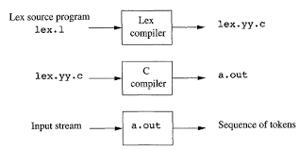
Figure 3. The translation using Lex

When the lexical analyzer finds identifiers in the input stream it enters them in a symbol table. The symbol table may also contain other information such as data type (integer or real) and location of the variable in memory. All subsequent references to identifiers refer to the appropriate symbol table index.
We code a grammar and input it to Yacc. Yacc will read the grammar and generate C code for a syntax analyzer or parser. The syntax analyzer uses grammar rules that allow it to analyze tokens from the lexical analyzer and create a syntax tree. The syntax tree imposes a hierarchical structure the tokens. The translation using Yacc as shown below. The below figure illustrate combined use and the file naming convention used by lex and yacc, such as “bas.y” for yacc compiler and “bas.l” for lex compiler.
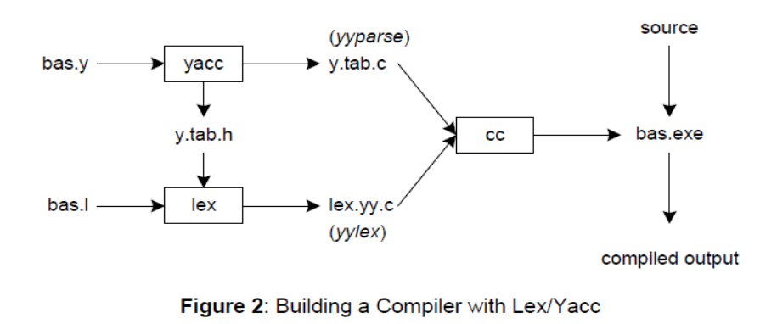
Figure 4. Lex and YACC compilers

First, we need to specify all pattern matching rules for lex (bas.l) and grammar rules for yacc (bas.y). Commands to create our compiler, bas.exe, are listed below:

yacc –d bas.y # create y.tab.h, y.tab.c
lex bas.l # create lex.yy.c
gcc -o bas y.tab.c lex.yy.c -ll # compile/link (output file name ‘bas.exe’)

Yacc reads the grammar descriptions in bas.y and generates a syntax analyzer (parser), that includes function yyparse, in file y.tab.c. Included in file bas.y are token declarations. The –d option causes yacc to generate definitions for tokens and place them in file y.tab.h. Lex reads the pattern descriptions in bas.l, includes file y.tab.h, and generates a lexical analyzer, that includes function yylex, in file lex.yy.c.
Finally, the lexer and parser are compiled and linked together to form the executable, bas.exe. From main, we call yyparse to run the compiler. Function yyparse automatically calls yylex to obtain each token.
More about Lex:

The first phase in a compiler reads the input source and converts strings in the source to tokens. Using regular expressions, we can specify patterns to lex so it can generate code that will allow it to scan and match strings in the input. Each pattern specified in the input to lex has an associated action. Typically an action returns a token that represents the matched string for subsequent use by the parser.
The following represents a simple pattern, composed of a regular expression, that scans for identifiers. Lex will read this pattern and produce C code for a lexical analyzer that scans for identifiers.
Letter (letter | digit)*

This pattern matches a string of characters that begins with a single letter followed by zero or more letters or digits. Any regular expression expressions may be expressed as a finite state automaton (FSA). We can represent an FSA using states, and transitions between states. There is one start state, and one or more final or accepting states.
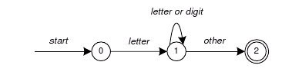

Figure 5. Finite State Automaton

This is the technique used by lex. Regular expressions are translated by lex to a computer program that mimic an FSA. Regular expressions in lex are composed of meta characters (Table 1). Pattern-matching examples are shown in Table 2. Within a character class, normal operators lose their meaning.
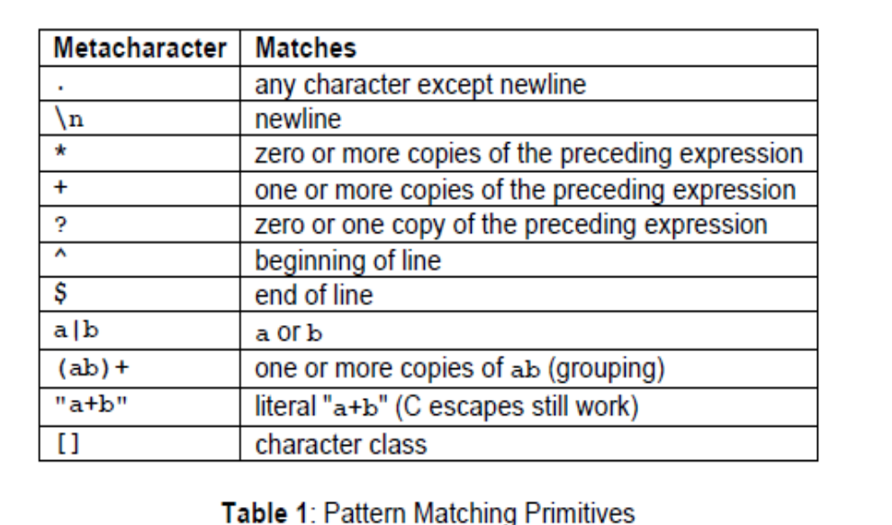

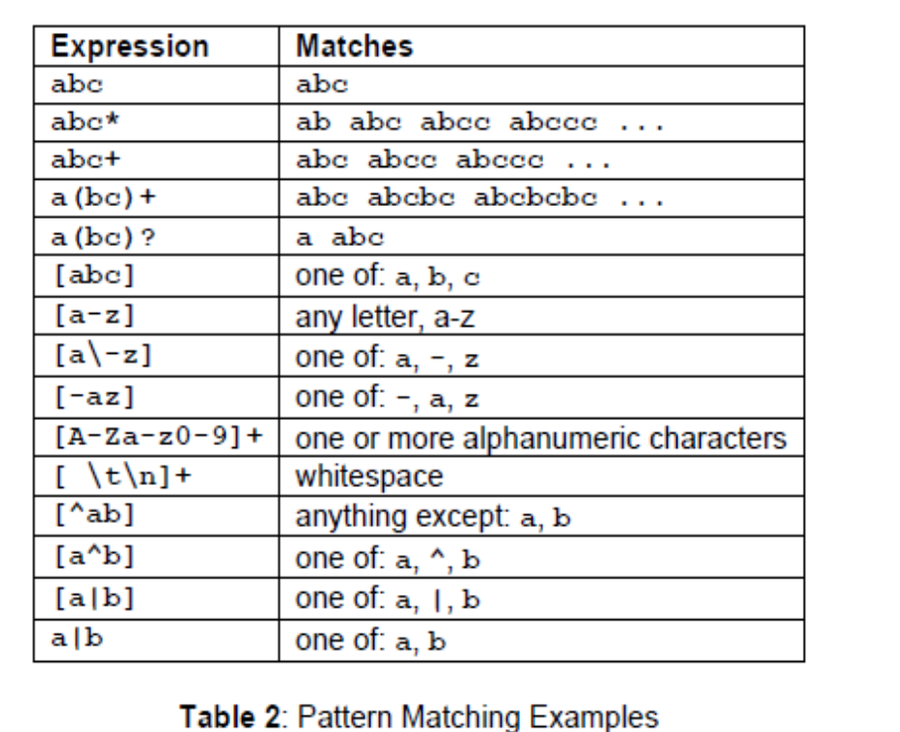

Two operators allowed in a character class are the hyphen (“-”) and circumflex (“^”). When used between two characters, the hyphen represents a range of characters. The circumflex, when used as the first character, negates the expression. If two patterns match the same string, the longest match wins. In case both matches are the same length, then the first pattern listed is used.
Lex Format:

... definitions ...
%%
... rules ...
%%
... subroutines ...

Input to Lex is divided into three sections, with %% dividing the sections. This is best illustrated by example. The first example is the shortest possible lex file.
%%
Input is copied to output, one character at a time. The first %% is always required, as there must always be a rules section. However, if we don’t specify any rules, then the default action is to match everything and copy it to output.

Defaults for input and output are stdin and stdout, respectively.
Here is the same example, with defaults explicitly coded.
%%
/* match everything except newline */
. ECHO;
/* match newline */
\n ECHO;
%%
int yywrap(void)
{
return 1;
}
int main(void)
{
yylex();
return 0;
}

Two patterns have been specified in the rules section. Each pattern must begin in column one. This is followed by whitespace (space, tab or newline), and an optional action associated with the pattern. The action may be a single C statement, or multiple C statements enclosed in braces. Anything not starting in column one is copied exactly to the generated C file (Comments can copied from lex file to C file). In this example there are two patterns, “.” and “\n”, with an ECHO action associated for each pattern. Several macros and variables are predefined by lex. ECHO is a macro that writes code matched by the pattern. This is the default action for any unmatched strings. Typically, ECHO is defined as
#define ECHO fwrite(yytext, yyleng, 1, yyout)

Variable yytext is a pointer to the matched string (NULL-terminated), and yyleng is the length of the matched string. Variable yyout is the output file, and defaults to stdout. Function yywrap is called by lex when input is exhausted. Return 1 if you are done, or 0 if more processing is required. Every C program requires a main function. In this case, we simply call yylex, the main entry-point for lex. Some implementations of lex include copies of main and yywrap in a library, eliminating the need to code them explicitly.
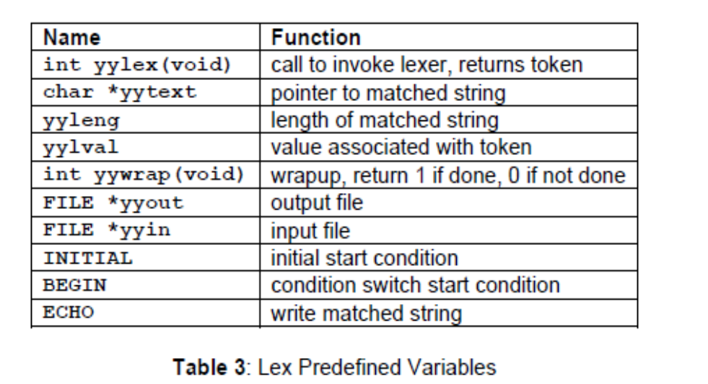

yywrap():
This function is called when end of file(or input) is encountered. If it return 1, the parsing stops. So this can be used to parse multiple files. Code can be written in third section, which will allow multiple file to be parsed.
yylineno: Provides current line number information.

Sample Program: Lexical Analyzer for C programming language

letter [a-zA-Z]
digit [0-9]
%%
{digit}+("E"("+"|"-")?{digit}+)? printf("\n%s\tis real number",yytext);

{digit}+"."{digit}+("E"("+"|"-")?{digit}+)? printf("\n%s\tis a float number",yytext);

"if"|"else"|"int"|"float"|"switch"|"case"|"struct"|"char"|"return"|"for"|"do"|"while"|"void"|"printf"|"scanf" printf("\n%s\tis a keyword",yytext);

"\t"|"\b"|"\\n"|"\\t"|"\\a"|"\\b"|"\a" printf("\n%s\tis an escape sequences",yytext);

{letter}({letter}|{digit})* printf("\n%s\tis an identifier",yytext);

"["|"]"|"{"|"}"|"("|")"|"#"|"'"|"""|"\"|"\\"|";"|"," printf("\n%s\t is a special character",yytext);

"&&"|"<"|">"|"<="|">="|"+"|"="|"-"|"?"|"/"|"||"|"*"|"&"|"%" printf("\n%s\t is an operator",yytext);

"%d"|"%s"|"%c"|"%f"|"%e" printf("\n%s\tis a format specifier",yytext);

%%
int yywrap()
{
return 1;}
int main(int argc, char *argv[])
{
yyin=fopen(argv[1],"r");
yylex();
fclose(yyin);
return 0;
}

When the generated scanner is run, it analyzes its input looking for strings which match any of its patterns. If it find more than one match, it take the one matching the most text. If it find two or more matches of the same length, the rule listed first in the flex input file is chosen.
Once the match is determined which satisfying one of the regular expression or rule, the text corresponding to the match (token) is made available in the global character pointer yytext and its length in the global integer yyleng. The action corresponding to the matched pattern is then executed and then the remaining input is scanned for another match. If no match is found, then the default rule is executed.

YACC (Yet Another Compiler Compiler)

YACC is an LALR parser generator. The first version of YACC was created by S.C Johnson. Yacc translate a yacc file into a C file y.tab.c using LALR method
A Yacc source program has three parts:
Declarations
%%
Translation rules
%%
Supporting C- routines

The Declarations parts:
There are two optional sections in the declarations part of the Yacc program. In the first section put ordinary C declarations, delimited by %{ and %}. Here we place any temporaries used by the translation rules or procedures of the second and third sections. Also in the declarations part are declarations of grammar tokens.
Each grammar rule defines a symbol in terms of: Other symbols (Non terminals) and tokens (terminals) which come from the lexical analyzer.
Terminal symbols are of three types:
Named token: Defined via the %token identifier. By convention these are all uppercase
Character token: As same as character constant written in c language, Eg: + is a character
Constant: Literal string constant. Like C string constant Eg: “abc” is string constant.
The Lexer returns named tokens. Non terminals are usually represented by using lower case letters.

A few Yacc specific declarations which begins with a % sign in Yacc specification file

- %union. It defines the stack type for the parser. It is union of various data/ structures/ objects
- %token. These are terminals return by the yylex function to the yacc.
%token NUM NUM is a named token
- %type. The type of non-terminal symbol in the grammar can be specified by using this rule.
- %nonassoc. Specifies that there is no associativity of a terminal symbol
%nonassoc ´<´ no associativity
- %left. Specifies that there is left associativity of a terminal symbol
%left ´+´ ´ - ´ make + and – be the same precedence and left associative
- %right. Specifies that there is right associativity of a terminal symbol
%right ´+´ ´- ´ make + and – be the same precedence and right associative
- %start. Specifies that the L.H.S non terminal symbol of production rule which should be taken as the starting point of the grammar rules.
- %prec. Change the precedence level associated with a particular rule to that of the following token name or literal. %prec <terminal>
%left ´+´ ´ - ´
%right ´*´ ´/´
The above two statements declare the associativity and precedence exist among the tokens. The precedence of the token increases from top to bottom, so the bottom listed rule has the highest precedence compared to the rule listed above it. Here * and / have the higher precedence than the addition and subtraction.

Translation rules part:
After the first %% put the translation rules. Each rule consists of a grammar production and the associated semantic action. Consider this production
<Left_side> → <alt 1>| <alt 2>|............|<alt n>

would be written in yacc as
<left_side> : <alt 1> { semantic action 1}
| <alt 2> { semantic action 2}
….........................................
| <alt n> { semantic action n}
;
In Yacc production, quoted single character ´ c ´ is taken to be the terminal c and unquoted strings letter and digits not declare to be token to be taken as nonterminals.
The Yacc semantic action is a sequence of C statements, In a semantic action the symbol $$ refers to the attribute value associated with non terminals on the left, while $i refers to the value associated with the i^{th} grammar symbol(terminal or non terminals ) on the right. The semantic action is performed whenever we reduce by the associated production, So normally the semantic action computes a value for $$ in terms of the $i´s.
Example: Here the non-terminal term in the first production is the third grammar symbol on the right, while ´+´ is the second terminal symbol. We have omitted the semantic action for the second production, since copying the value is the default action for productions with a single grammar symbol on the right. ($$= $1) is the default action.

Supporting C routines part:

The third part of the yacc specification consists of supporting C- routines. A lexical analyzer by the name yylex() must be provided . Other procedures such as error recover routine may be added as necessary. The lexical analyzer yylex() produce pair consists of a token and its associated attribute value. The attribute value associated with a token is communicated to the parser through a yacc defined variable yylval.

How to compile Yacc and Lex files

- Write a parser for a given grammar in a .y file
- Write the lexical analyzer to process input and pass tokens to the parser when it needed, save the file as .l file
- write error handler routine(like yyerror())
- Compile .y file using the command yacc -d <filename.y> then it generate two file y.tab.c amd y.tab.h. If you are using bison, it generate <filename>.tab.c and <filename>.tab.h respectively
- Compile lex file using the command flex <filename.l> it generate lex.yy.c
- Compile the c file generated by the yacc compiler using gcc y.tab.c -ll it will generate .exe file a.out
- Run the executable file and give the necessary input

History of lex and Yacc

Bison is descended from yacc, a parser generator written between 1975 and 1978 by Stephen C. Johnson at Bell Labs. As its name, short for “yet another compiler compiler,” suggests, many people were writing parser generators at the time. Johnson’s tool combined a firm theoretical foundation from parsing work by D. E. Knuth, which made its parsers extremely reliable, and a convenient input syntax. These made it extremely popular among users of Unix systems, although the restrictive license under which Unix was distributed at the time limited its use outside of academia and the Bell System.
In about 1985, Bob Corbett, a graduate student at the University of California, Berkeley, re-implemented yacc using somewhat improved internal algorithms, which evolved into Berkeley yacc. Since his version was faster than Bell’s yacc and was distributed under the flexible Berkeley license, it quickly became the most popular version of yacc. Richard Stallman of the Free Software Foundation (FSF) adapted Corbett’s work for use in the GNU project, where it has grown to include a vast number of new features as it has evolved into the current version of bison.
Bison is now maintained as a project of the FSF and is distributed under the GNU Public License. In 1975, Mike Lesk and summer intern Eric Schmidt wrote lex, a lexical analyzer generator, with most of the programming being done by Schmidt. They saw it both as a standalone tool and as a companion to Johnson’s yacc. Lex also became quite popular, despite being relatively slow and buggy. (Schmidt nonetheless went on to have a fairly successful career in the computer industry where he is now the CEO of Google.) In about 1987, Vern Paxson of the Lawrence Berkeley Lab took a version of lex written in rat for (an extended Fortran popular at the time) and translated it into C, calling it flex, for “Fast Lexical Analyzer Generator.” Since it was faster and more reliable than AT&T lex and, like Berkeley yacc, available under the Berkeley license, it has completely supplanted the original lex. Flex is now a SourceForge project, still under the Berkeley license.
A flex program consists of three sections, separated by %% lines. The first section contains declarations and option settings. The second section is a list of patterns and actions, and the third section is C code that is copied to the generated scanner, usually small routines related to the code in the actions. In the declaration section, code inside of %{ and %} is copied through verbatim near the beginning of the generated C source file. In this case it just sets up variables for lines, words, and characters.

The commands for executing the LEX program are:
  - lex abc.l (abc is the file name)
  - cc lex.yy.c -efl
  - ./a.out

Practice Questions:

    - Write a program to construct a small calculator that can add, subtract, multiply and divide in LEX.

% {
int op = 0,i;
float a, b;
% }

dig [0-9]+|([0-9]*)"."([0-9]+)
add "+"
sub "-"
mul "*"
div "/"
pow "^"
ln \n
%%

/* digi() is a user defined function */
{dig} {digi();}
{add} {op=1;}
{sub} {op=2;}
{mul} {op=3;}
{div} {op=4;}
{pow} {op=5;}
{ln} {printf("\n The Answer :%f\n\n",a);}

%%
digi()
{
if(op==0)

/* atof() is used to convert
- the ASCII input to float */
a=atof(yytext);

else
{
b=atof(yytext);

switch(op)
{
case 1:a=a+b;
break;

case 2:a=a-b;
break;

case 3:a=a*b;
break;

case 4:a=a/b;
break;

case 5:for(i=a;b>1;b--)
a=a*i;
break;
}
op=0;
}
}

main(int argv,char *argc[])
{

yylex();
}

yywrap()
{
return 1;
}
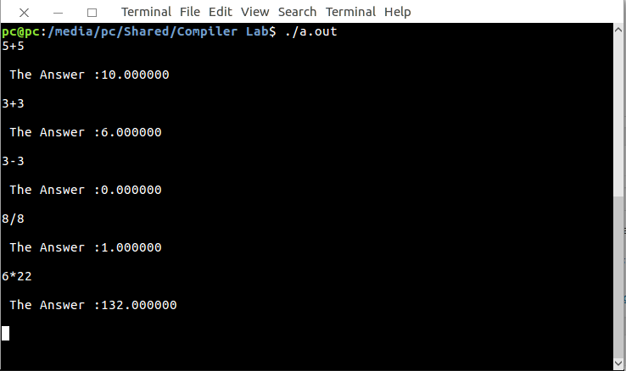

    - Write a program to match a string in LEX.

Viva Questions:

- Explain LEX and YACC tools briefly.

Lex:- scanner that can identify those tokens

Yacc:- parser.yacc takes a concise description of a grammar and produces a C routine that can parse that grammar.

- Give the structure of the LEX program.

definition section- any intitial ‘c’ program code
% %
Rules section- pattern and action separated by white space
%%
User subroutines section-concsit of any legal code.

- Explain the structure of a YACC program.

Defn section- declarations of the tokens used in the grammar
%%
The rules section-pattern action
%%
Users subroutines section

- What are tokens or terminal symbols?

Symbols that appear in the input are returned by the lexer are terminal symbols.

- What is lexical analyzer?

Lex taking a set of descriptions of possible tokensand producing a ‘C” routine is called a lexical analyzer (or) lexer (or) scanner.

- Discuss about the input buffering scheme in lexical analyzer.

